# SASS - Lab

Problems for exercises and homework for the ["CSS Advanced" course @ SoftUni](https://softuni.bg/trainings/3042/css-advanced-july-2020).

**Trainings Page**

Create a web page using the [following design](https://www.figma.com/file/D1hWjDJ2oDVSAXWz3TnmgM/CSS-Advanced?node-id=1%3A26). Add scss files in your project and fill your architecture from the previous workshop.

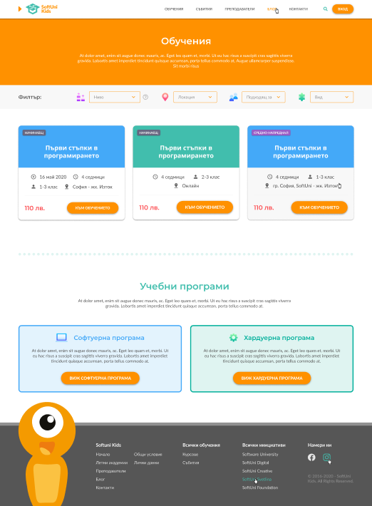

### Constraints

* Convert and refactor all css files into scss files
* In your project directory update your /settings folder with the following files:
  + Add settings-colors.scss stylesheet
  + Add settings-breakpoints.scss stylesheet (Use the [following stylesheet](https://www.freecodecamp.org/news/the-100-correct-way-to-do-css-breakpoints-88d6a5ba1862/) here or create one by yourself)

### Hints

* Use the [following](https://marketplace.visualstudio.com/items?itemName=refgd.easy-compile) vscode extension to compile your scss code to css